DCC-GARCH correlation: USDJPY and USDCHF
Method 09 / GARCH(1,1) + Engle DCC / Alpari D1 full available history

Study setup
Logical pair: USDJPY , USDCHF
Broker symbols: USDJPY_i , USDCHF_i
Snapshot: 2026-11-03_majors_alpari_D1
Timeframe: D1
Matched return window: 1999-01-05 to 2026-11-02 (UTC bar dates)
Matched return count n: 7185
Dropped unfinished last bar dated 2026-11-03 UTC after a tick-volume check against the prior complete day.
USDJPY GARCH(1,1): mu=0.000109, omega=0.005086, alpha=0.052475, beta=0.934665
USDCHF GARCH(1,1): mu=-0.000340, omega=0.003461, alpha=0.040947, beta=0.956766
DCC: a=0.079012, b=0.885271, a+b=0.964283
Burn-in ignored in path summaries and chart: first 60 updates
Complete matched rows (Excel): USDJPY-USDCHF_DCC_D1.xlsx
Complete matched rows (HTML table): USDJPY-USDCHF_DCC_D1_data.html

Method carried forward
DCC-GARCH first fits a constant-mean GARCH(1,1) on each matched daily log return of close, ln(close_t / close_t-1), then updates Engle (2002) dynamic conditional correlation on the standardised shocks z = residual / conditional sigma. Quotes are not inverted. Correlation targeting sets Q_bar to the sample correlation of z; a and b are estimated by maximising the bivariate Gaussian DCC likelihood with a >= 0, b >= 0, and a + b < 1. Path summaries ignore the first 60 updates. The headline is rho on the last day. Same-sample Pearson r on log returns is a side check only. A high |rho| does not prove cause, lead-lag, or a trading signal.

Results
Latest DCC rho: 0.473808
Post-burn-in path (n=7125): mean=0.451435, median=0.483952, min=-0.423904, max=0.863717, std=0.188768
Share of post-burn-in days with |rho| >= 0.4: 67.72%; |rho| >= 0.7: 5.08%
Same-sample Pearson r: 0.399461
Latest rho minus r: 0.074348

Conclusion
Over 7185 matched daily log-return rows for USDJPY and USDCHF (broker quote directions unchanged), latest DCC rho is 0.4738 (positive, moderate conditional linear link in this sample) with fitted a=0.0790, b=0.8853 (a+b=0.9643). After a 60-day burn-in, path mean is 0.4514 and std is 0.1888. Same-sample Pearson r is 0.3995 (latest rho minus r = 0.0743). This does not establish cause, lead-lag, or a lasting trading rule.

Charts
Daily closes

Daily log returns
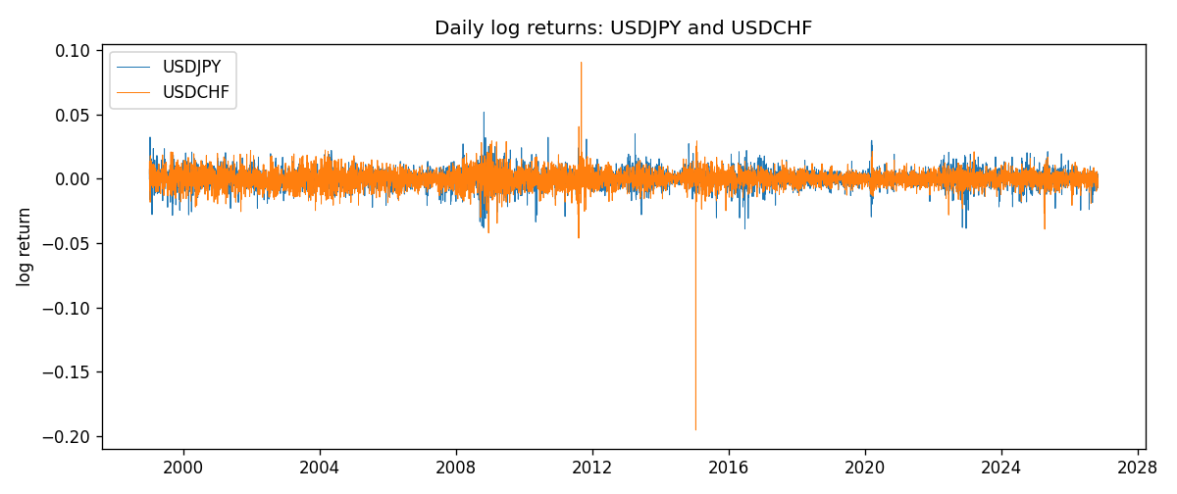
DCC rho path with Pearson r reference
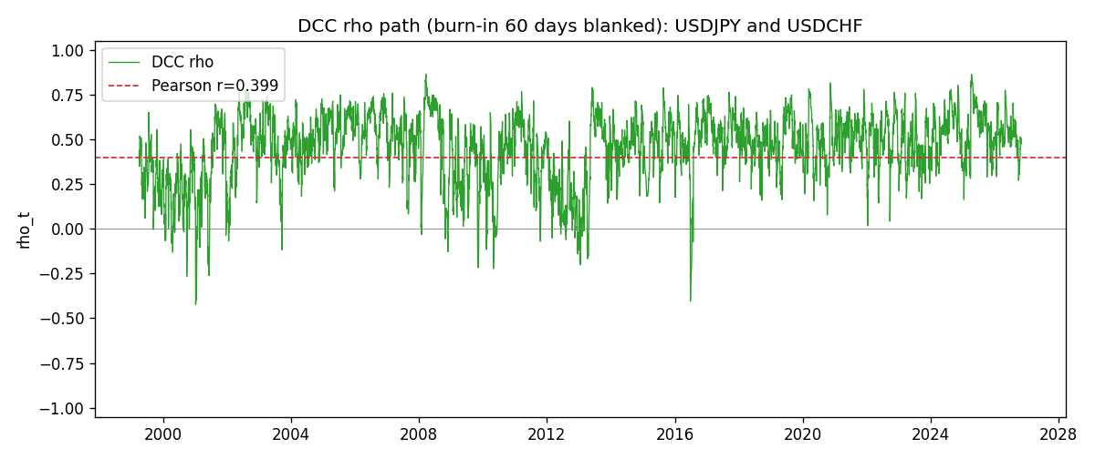

Data report
Every matched row that entered the DCC recursion is stored in the sibling Excel workbook named USDJPY-USDCHF_DCC_D1.xlsx. Embedding all rows as a Word table is impractical at this length; the Word file holds the column list, column summaries, and the first and last 15 matched rows.
Columns: time, USDJPY_open, USDCHF_open, USDJPY_high, USDCHF_high, USDJPY_low, USDCHF_low, USDJPY_close, USDCHF_close, USDJPY_tick_volume, USDCHF_tick_volume, USDJPY_spread, USDCHF_spread, USDJPY_real_volume, USDCHF_real_volume, USDJPY_log_return, USDCHF_log_return, USDJPY_sigma, USDCHF_sigma, USDJPY_z, USDCHF_z, q11, q22, q12, rho_t
Column summaries (matched calculation rows)
column | count | mean | std | min | 25% | 50% | 75% | max
USDJPY_open | 7185 | 113.80726 | 19.2236 | 75.693 | 104.38 | 110.984 | 120.69 | 163.824
USDCHF_open | 7185 | 1.0974395 | 0.25223318 | 0.72022 | 0.92053 | 0.98988 | 1.2375 | 1.8219
USDJPY_high | 7185 | 114.30433 | 19.285132 | 76.001 | 104.865 | 111.442 | 121.257 | 163.978
USDCHF_high | 7185 | 1.1027315 | 0.25397793 | 0.73305 | 0.92474 | 0.99353 | 1.2422 | 1.8313
USDJPY_low | 7185 | 113.28455 | 19.151449 | 75.402 | 103.87 | 110.53 | 120.17 | 163.628
USDCHF_low | 7185 | 1.0923205 | 0.25064913 | 0.08565 | 0.91719 | 0.98622 | 1.2315 | 1.8121
USDJPY_close | 7185 | 113.82023 | 19.238853 | 75.811 | 104.38 | 111.025 | 120.68 | 163.851
USDCHF_close | 7185 | 1.0974333 | 0.25214008 | 0.72025 | 0.92079 | 0.98995 | 1.2376 | 1.8217
USDJPY_tick_volume | 7185 | 106345.59 | 179437.4 | 149 | 9958 | 53202 | 92889 | 1803508
USDCHF_tick_volume | 7185 | 74334.331 | 113494.7 | 18 | 12809 | 40241 | 70443 | 858589
USDJPY_spread | 7185 | 20.263883 | 17.612444 | 0 | 6 | 11 | 30 | 50
USDCHF_spread | 7185 | 26.03215 | 24.694045 | 0 | 5 | 16 | 50 | 100
USDJPY_real_volume | 7185 | 3.4781051e+10 | 1.6093614e+11 | 0 | 0 | 0 | 0 | 3.8834203e+12
USDCHF_real_volume | 7185 | 2.3294091e+10 | 8.9133595e+10 | 0 | 0 | 0 | 0 | 1.9331921e+12
USDJPY_log_return | 7185 | 4.82e-05 | 0.00620617 | -0.03908203 | -0.00320044 | 0.00011473 | 0.00340924 | 0.05184024
USDCHF_log_return | 7185 | -6.962e-05 | 0.0065941 | -0.19545699 | -0.0033516 | 8.06e-05 | 0.00332472 | 0.09051364
USDJPY_sigma | 7185 | 0.00599272 | 0.00174266 | 0.00337621 | 0.00477359 | 0.0056926 | 0.0067959 | 0.01887346
USDCHF_sigma | 7185 | 0.00655133 | 0.00254611 | 0.0036198 | 0.00508548 | 0.00610218 | 0.00732184 | 0.03987328
USDJPY_z | 7185 | -0.00895857 | 1.0002822 | -6.5271245 | -0.56277723 | 0.00086487 | 0.58046969 | 7.1061132
USDCHF_z | 7185 | 0.03929992 | 0.99910224 | -34.471757 | -0.48035331 | 0.0698323 | 0.59701607 | 6.7476623
q11 | 7185 | 1.0008335 | 0.3817716 | 0.42720536 | 0.76371031 | 0.91277813 | 1.125708 | 4.6457652
q22 | 7185 | 0.99995877 | 2.3812732 | 0.45129738 | 0.71700965 | 0.83502955 | 0.99638843 | 94.579621
q12 | 7185 | 0.42968692 | 0.27681251 | -0.76744898 | 0.27825722 | 0.39779448 | 0.54429293 | 4.6229976
rho_t | 7185 | 0.45044928 | 0.18887587 | -0.42390432 | 0.35047413 | 0.48295127 | 0.58418402 | 0.86371656
First 15 matched rows (selected columns)
time | USDJPY_log_return | USDCHF_log_return | USDJPY_sigma | USDCHF_sigma | USDJPY_z | USDCHF_z | q11 | q22 | q12 | rho_t
1999-01-05 | -0.00017868311 | 0.0039424743 | 0.011247964 | 0.0083861703 | -0.025597847 | 0.51068711 | 1 | 1 | 0.42989924 | 0.42989924
1999-01-06 | 0.0075660159 | 0.013605652 | 0.010897874 | 0.0082694913 | 0.68424128 | 1.6864262 | 0.92103946 | 0.9415942 | 0.39489902 | 0.42404803
1999-01-07 | -0.012851583 | -0.0093883841 | 0.010697225 | 0.0085870727 | -1.2116061 | -1.0536943 | 0.88807871 | 1.0939964 | 0.45612132 | 0.46275028
1999-01-08 | -0.0047719894 | 0.011040268 | 0.01078322 | 0.0086167447 | -0.45266907 | 1.3207427 | 0.93789629 | 1.0919251 | 0.52001759 | 0.51385928
1999-01-11 | -0.016195423 | 0.0052963193 | 0.010509029 | 0.008757151 | -1.5514909 | 0.64365158 | 0.88219945 | 1.1401923 | 0.42847278 | 0.42721924
1999-01-12 | 0.032310364 | -0.0098275602 | 0.010848171 | 0.0086613655 | 2.9683459 | -1.0953614 | 1.0068948 | 1.0778296 | 0.31576587 | 0.30310848
1999-01-13 | 0.0081373171 | -0.018259701 | 0.012841915 | 0.0087067587 | 0.62514636 | -2.0581099 | 1.623275 | 1.0846882 | 0.037991446 | 0.028631052
1999-01-14 | 0 | -0.0024256692 | 0.012571026 | 0.0092749528 | -0.0086898675 | -0.22484582 | 1.5036334 | 1.3306413 | -0.052671366 | -0.037236864
1999-01-15 | 0.0055343401 | 0.01794228 | 0.012174358 | 0.0091010874 | 0.4456169 | 2.0088275 | 1.3668455 | 1.2176893 | -0.031119301 | -0.024121365
1999-01-18 | 8.7600193e-05 | -0.0031856384 | 0.011856829 | 0.0096582334 | -0.001825139 | -0.29460911 | 1.2614351 | 1.4325469 | 0.058534982 | 0.043544029
1999-01-19 | -0.0056219403 | -7.2518946e-05 | 0.011485117 | 0.0094829435 | -0.49900935 | 0.028231301 | 1.1524287 | 1.3107666 | 0.067216518 | 0.054689794
1999-01-20 | -0.0053879917 | 0.0072259871 | 0.011203657 | 0.0092944843 | -0.49066411 | 0.81405505 | 1.0756033 | 1.1961632 | 0.073746442 | 0.065015932
1999-01-21 | 0.0084664056 | -0.0038232689 | 0.010927731 | 0.0092381193 | 0.76476671 | -0.37702848 | 1.0069394 | 1.1470056 | 0.049080595 | 0.04566941
1999-01-22 | 0.0060412564 | -0.0001445609 | 0.010760431 | 0.0090827331 | 0.5512805 | 0.021543503 | 0.97334268 | 1.062359 | 0.036022025 | 0.035424162
1999-01-25 | -0.0073594164 | 0.0024546976 | 0.010515563 | 0.0089037705 | -0.71024794 | 0.31390437 | 0.92140139 | 0.97622897 | 0.048182364 | 0.050802821
Last 15 matched rows (selected columns)
time | USDJPY_log_return | USDCHF_log_return | USDJPY_sigma | USDCHF_sigma | USDJPY_z | USDCHF_z | q11 | q22 | q12 | rho_t
2026-10-13 | -0.0018932826 | -0.0024955621 | 0.0048650817 | 0.0047783344 | -0.41161141 | -0.45106246 | 0.56385732 | 0.65507879 | 0.20857513 | 0.34318725
2026-10-14 | 7.5800166e-05 | 0.0029388325 | 0.0047792881 | 0.0047309305 | -0.0069969391 | 0.69311254 | 0.54826996 | 0.6317147 | 0.21466979 | 0.36476505
2026-10-15 | -0.0018524319 | -0.0097855323 | 0.0046752387 | 0.0047117378 | -0.41958766 | -2.0046314 | 0.52108821 | 0.63291344 | 0.20501241 | 0.35698698
2026-10-16 | -0.00037976126 | -0.0036230826 | 0.0045978545 | 0.0050239273 | -0.10635435 | -0.65344255 | 0.51093156 | 0.91353142 | 0.26330493 | 0.3854037
2026-10-19 | 0.0034946841 | 0.0036351779 | 0.0045033514 | 0.0049936021 | 0.75176092 | 0.79610122 | 0.48892349 | 0.87817684 | 0.25394193 | 0.38754575
2026-10-20 | -0.0022546642 | -0.0026281224 | 0.0044794149 | 0.0049851025 | -0.52772624 | -0.45894495 | 0.51320003 | 0.86321742 | 0.28744918 | 0.43187458
2026-10-21 | -0.00032883504 | -0.00040027413 | 0.0044222159 | 0.0049332858 | -0.099062463 | -0.012170256 | 0.5120425 | 0.81654049 | 0.28896162 | 0.44688759
2026-10-22 | -0.0085942669 | -0.0048036381 | 0.0043355428 | 0.0048612141 | -2.0074781 | -0.91816637 | 0.48978862 | 0.75858807 | 0.27125923 | 0.44501759
2026-10-23 | 0.00035080446 | 0.005652514 | 0.0046960031 | 0.0048756143 | 0.051440322 | 1.2291269 | 0.78772966 | 0.7738825 | 0.40112797 | 0.51375591
2026-10-26 | 0.0041238746 | 0.0018407959 | 0.0045960058 | 0.0049558606 | 0.87350501 | 0.44009122 | 0.73328006 | 0.84018059 | 0.37545723 | 0.47834277
2026-10-27 | 0.0027651658 | 0.0026100526 | 0.0045932013 | 0.0049030226 | 0.57822966 | 0.60172829 | 0.74515562 | 0.79480739 | 0.37811006 | 0.49131926
2026-10-28 | -0.00095679538 | -0.0010142111 | 0.0045384809 | 0.0048685581 | -0.23488827 | -0.13843448 | 0.72179917 | 0.76794523 | 0.37757578 | 0.50714345
2026-10-29 | -0.00038043789 | -0.0048680164 | 0.0044519933 | 0.0048002952 | -0.10999083 | -0.94322982 | 0.67906397 | 0.71707061 | 0.3521807 | 0.50469529
2026-10-30 | -0.0010596481 | 0.00071594559 | 0.0043642216 | 0.0048199787 | -0.26783441 | 0.21912553 | 0.63782834 | 0.74081448 | 0.33532723 | 0.4878229
2026-11-02 | 0.0026438521 | -0.0071459744 | 0.0042874569 | 0.0047560064 | 0.59116897 | -1.4309778 | 0.60603572 | 0.69533221 | 0.3075729 | 0.47380843

